PNEUMONIA DETECTION USING DEEP LEARNING
Conclusion, Future Scope and References
Department of Computer Science and Engineering, TKR College of Engineering and Technology (Autonomous)
Batch A12 (CSE-A) · Academic year 2026-2027
Table 1: Project team
S.No. | Student name | Roll number
1 | CHOUDAM AKSHITHA | 23K91A0556
2 | BOGGULA SATVIK KUMAR | 23K91A0541
3 | ARUTLA ABHI THEJ REDDY | 23K91A0515
4 | DUGGARAJU LIKHITHA | 23K91A0565

Project guide: V. MEENAKSHI
Chapter and section numbers quoted in the text (for example Section 6.6 or Chapter 8) refer to the full project report, 17.Final Document. Figures and tables in this document are numbered from 1.

CHAPTER 9: CONCLUSION

9.1 Summary
The project set out to build an explainable pneumonia detection system and to measure it honestly. It delivers a working pipeline in which a chest X-ray is validated, enhanced with CLAHE, classified by a compact CNN into Normal, Bacterial or Viral pneumonia, explained with a Grad-CAM heat map and stored with its result, behind a FastAPI service, a React interface and the original Flask interface. A reproducible training script, a patient-aware evaluation, ten design diagrams and an automated test suite complete the work.

9.2 Objectives achieved
Five of the six objectives were met: data preparation, a trained CNN classifier, the requested evaluation, heat-map visualisation and deployment behind an interface (Section 8.11). The second objective, U-Net lung segmentation, was not achieved: no segmentation network was implemented, so the classifier sees the whole radiograph.

9.3 Key findings
• A 590,019-parameter CNN trained on a desktop CPU reaches 79.5% three-class accuracy and macro F1 0.780 on the official 624-image test split.
• Viewed as pneumonia against normal, sensitivity is 98.7% and specificity 62.0%; normal radiographs are the weak point: 72 of 234 are called viral and 17 bacterial pneumonia (specificity 62.0%), and viral precision is 0.61; confusion between the two pneumonia types is smaller (29 viral called bacterial, 5 bacterial called viral).
• The official test folder shares pneumonia ids with the training folders; the id-disjoint and patient-level results in Chapter 8 should be preferred when judging generalisation.
• Reported accuracy on the same public images varies from about 80 % to 98 % across studies with different protocols, so numbers must be quoted with their protocol.
• The shipped Grad-CAM works only on flat networks; transfer-learning backbones need a Grad-CAM that reaches nested layers.
• The system is verified by 73 automated tests plus a live smoke test and browser checks.

9.4 Practical applications
• A teaching tool: students can upload a radiograph, see the probabilities and the heat map, and study where a CNN looks.
• A research scaffold: the training script, evaluation protocol and application can be reused with other chest X-ray datasets or models.
• A triage-support prototype: with proper validation, confidence thresholds could flag low-confidence scans for review.

9.5 Known limitations
• No U-Net segmentation. One of the six stated objectives was not met; the model may use image regions outside the lungs, and the Grad-CAM maps in Chapter 8 show that it sometimes does.
• Single data source. All training and test images come from one paediatric centre. The official test split is known to differ in distribution from the training split, and no external hospital data were available, so the reported figures say little about performance elsewhere.
• Modest absolute accuracy. Normal radiographs are often called pneumonia and the two pneumonia types overlap on a radiograph alone; the confusion matrix in Chapter 8 shows where the model fails.
• CPU-only training. All training was run on a desktop CPU (no GPU), which limited the number of experiments and made large backbones impractical.
• Class labels from file names. Pathogen type is not independently verified by the authors of this project.
• Uncalibrated probabilities. Confidence is the raw softmax output; no temperature scaling or Monte Carlo Dropout is applied, so a high confidence is not a guarantee of correctness.
The figures below summarise the measurements behind the conclusions: the left chart compares every experiment on the same 624 official test images, the right one gives the per-class precision, recall and F1 of the deployed model.
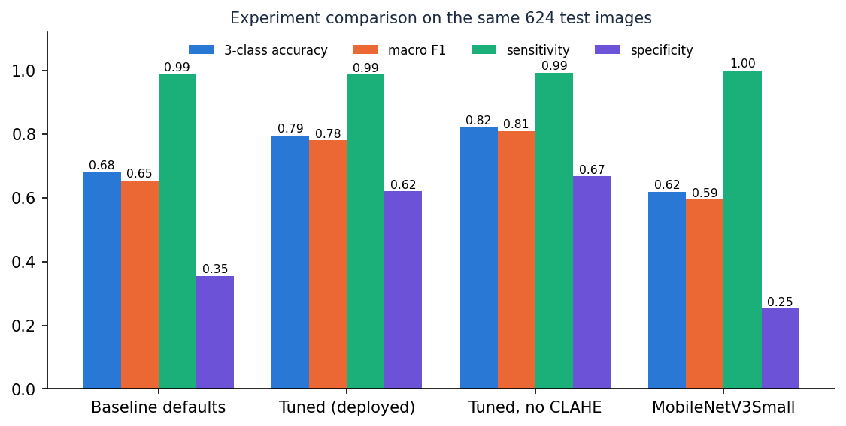
Figure 1: Experiments compared on the official test images
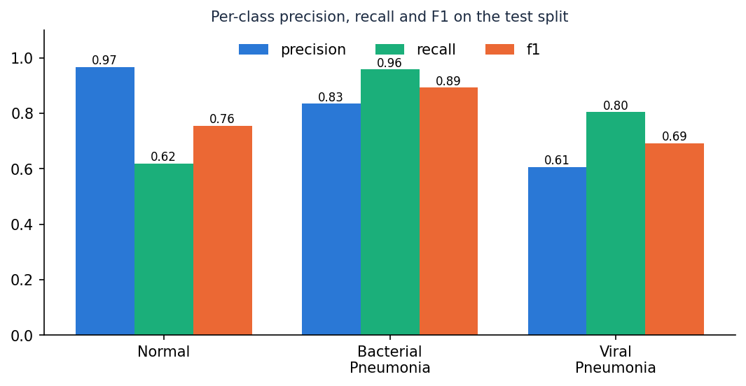
Figure 2: Per-class precision, recall and F1 of the deployed model

CHAPTER 10: FUTURE SCOPE

10.1 Improvements to the model
• U-Net lung segmentation (objective 2): train a segmentation network [10] on lung masks and classify only the lung region, which should also make Grad-CAM maps more specific.
• Transfer learning with a Grad-CAM that reaches nested backbones (for example by building a flat model from the backbone's layers), so that MobileNetV3Small, EfficientNet or DenseNet can be deployed with explanations.
• Calibrated uncertainty: temperature scaling and Monte Carlo Dropout [15] so that confidence tracks accuracy, and an automatic 'send for review' flag.
• Orientation-safe augmentation: remove horizontal flips, as the base paper does, and measure the effect.
• Repeated runs and cross-validation at patient level to give confidence intervals.

10.2 Additional features
• Real user accounts and roles, an audit log of who analysed which scan, and per-user histories.
• DICOM input and metadata handling; batch upload; PDF report generation.
• A reviewer workflow in which a clinician confirms or corrects a prediction, feeding a labelled set for retraining.
• Multi-language interface and printable reports for the target clinics.

10.3 Scalability and deployment
• Package the API and the built front end in containers behind a reverse proxy with HTTPS; replace SQLite by a server database and the local folders by object storage.
• Serve the model from a dedicated inference process or a GPU host with a queue, instead of the in-process lock.
• Add monitoring of latency, error rates and the distribution of predicted classes to detect drift.

10.4 Further research
• External validation on adult and multi-hospital data and a prospective clinical study.
• Semi-supervised learning with FixMatch, FlexMatch or FreeMatch [1], [14] to use unlabelled radiographs.
• A study of how clinicians use the heat map, and whether it improves or biases their decisions.
• Joint modelling of segmentation, classification and uncertainty in one network.

REFERENCES
[1] S. M. Mahin, T. Hasan, S. Karim, M. B. R. Nuha, E. H. Tusher, A. R. Hussain, J. Uddin, and D. Ghose, "From pneumonia to multi-disease: Interpretable and uncertainty-aware semi-supervised learning strategies for chest X-ray classification," IEEE Access, vol. 14, pp. 127532-127551, 2026, doi: 10.1109/ACCESS.2026.3722370.
[2] World Health Organization, "Pneumonia," fact sheet, 2024. [Online]. Available: https://www.who.int/news-room/fact-sheets/detail/pneumonia
[3] D. S. Kermany et al., "Identifying medical diagnoses and treatable diseases by image-based deep learning," Cell, vol. 172, no. 5, pp. 1122-1131, Feb. 2018.
[4] D. Kermany, K. Zhang, and M. Goldbaum, "Labeled optical coherence tomography (OCT) and chest X-ray images for classification," Mendeley Data, v3, 2018, doi: 10.17632/rscbjbr9sj.3.
[5] A. O. Khadidos, A. Nanyonga, A. O. Khadidos, O. M. Mirza, and M. T. Yilmaz, "Explainable deep learning for pediatric pneumonia detection in chest X-ray images," arXiv:2601.09814, Jan. 2026.
[6] K. Shahi and A. Bagale, "Weakly supervised pneumonia localization from chest X-rays using deep neural network and Grad-CAM explanations," arXiv:2511.00456, 2025.
[7] P. Rajpurkar et al., "CheXNet: Radiologist-level pneumonia detection on chest X-rays with deep learning," arXiv:1711.05225, 2017.
[8] X. Wang, Y. Peng, L. Lu, Z. Lu, M. Bagheri, and R. M. Summers, "ChestX-ray8: Hospital-scale chest X-ray database and benchmarks on weakly-supervised classification and localization of common thorax diseases," in Proc. IEEE Conf. Comput. Vis. Pattern Recognit. (CVPR), Jul. 2017, pp. 3462-3471.
[9] R. R. Selvaraju, M. Cogswell, A. Das, R. Vedantam, D. Parikh, and D. Batra, "Grad-CAM: Visual explanations from deep networks via gradient-based localization," Int. J. Comput. Vis., vol. 128, no. 2, pp. 336-359, Feb. 2020.
[10] O. Ronneberger, P. Fischer, and T. Brox, "U-Net: Convolutional networks for biomedical image segmentation," in Proc. Med. Image Comput. Comput.-Assist. Intervent. (MICCAI), 2015, pp. 234-241.
[11] K. Zuiderveld, "Contrast limited adaptive histogram equalization," in Graphics Gems IV, P. S. Heckbert, Ed. San Diego, CA, USA: Academic Press, 1994, pp. 474-485.
[12] A. G. Howard et al., "MobileNets: Efficient convolutional neural networks for mobile vision applications," arXiv:1704.04861, 2017.
[13] A. Howard et al., "Searching for MobileNetV3," in Proc. IEEE/CVF Int. Conf. Comput. Vis. (ICCV), Sep. 2019, pp. 1314-1324.
[14] K. Sohn et al., "FixMatch: Simplifying semi-supervised learning with consistency and confidence," in Proc. Adv. Neural Inf. Process. Syst., vol. 33, 2020, pp. 596-608.
[15] Y. Gal and Z. Ghahramani, "Dropout as a Bayesian approximation: Representing model uncertainty in deep learning," in Proc. Int. Conf. Mach. Learn. (ICML), 2016, pp. 1050-1059.
[16] D. P. Kingma and J. Ba, "Adam: A method for stochastic optimization," arXiv:1412.6980, 2014.
[17] S. Ioffe and C. Szegedy, "Batch normalization: Accelerating deep network training by reducing internal covariate shift," in Proc. Int. Conf. Mach. Learn. (ICML), 2015, pp. 448-456.
[18] N. Srivastava, G. Hinton, A. Krizhevsky, I. Sutskever, and R. Salakhutdinov, "Dropout: A simple way to prevent neural networks from overfitting," J. Mach. Learn. Res., vol. 15, pp. 1929-1958, 2014.
[19] M. Abadi et al., "TensorFlow: A system for large-scale machine learning," in Proc. 12th USENIX Symp. Oper. Syst. Design Implement. (OSDI), 2016, pp. 265-283.
[20] T. Ozturk, M. Talo, E. A. Yildirim, U. B. Baloglu, O. Yildirim, and U. R. Acharya, "Automated detection of COVID-19 cases using deep neural networks with X-ray images," Comput. Biol. Med., vol. 121, Art. no. 103792, Jun. 2020.
[21] L. Wang, Z. Q. Lin, and A. Wong, "COVID-Net: A tailored deep convolutional neural network design for detection of COVID-19 cases from chest X-ray images," Sci. Rep., vol. 10, no. 1, Art. no. 19549, Nov. 2020.
[22] F. Alshanketi et al., "Pneumonia detection from chest X-ray images using deep learning and transfer learning for imbalanced datasets," J. Imaging Inform. Med., vol. 38, no. 4, pp. 2021-2040, Nov. 2024.
[23] H. Malik, T. Anees, M. Din, and A. Naeem, "CDC_Net: Multi-classification convolutional neural network model for detection of COVID-19, pneumothorax, pneumonia, lung cancer, and tuberculosis using chest X-rays," Multimedia Tools Appl., vol. 82, no. 9, pp. 13855-13880, Apr. 2023.
[24] R. Kumar, C.-T. Pan, Y.-M. Lin, S. Yow-Ling, T.-S. Chung, and U. G. S. Janesha, "Enhanced multi-model deep learning for rapid and precise diagnosis of pulmonary diseases using chest X-ray imaging," Diagnostics, vol. 15, no. 3, p. 248, 2025.
[25] R. Siddiqi and S. Javaid, "Deep learning for pneumonia detection in chest X-ray images: A comprehensive survey," J. Imaging, vol. 10, no. 8, p. 176, Jul. 2024.
[26] M. F. Hashmi, A. A. Husain, D. M. Kotambkar, and K. D. Kumar, "Hybrid deep learning and handcrafted feature fusion for pneumonia detection in chest X-rays," J. Electr. Syst. Inf. Technol., vol. 12, no. 1, p. 94, Nov. 2025.
[27] R. Vyas and D. R. Khadatkar, "Ensemble of deep learning architectures with machine learning for pneumonia classification using chest X-rays," J. Imaging Inform. Med., vol. 38, no. 2, pp. 727-746, Aug. 2024.
[28] G. Litjens et al., "A survey on deep learning in medical image analysis," Med. Image Anal., vol. 42, pp. 60-88, 2017.
[29] C. Guo, G. Pleiss, Y. Sun, and K. Q. Weinberger, "On calibration of modern neural networks," in Proc. Int. Conf. Mach. Learn. (ICML), 2017, pp. 1321-1330.
[30] "Pneumonia detection from chest X-ray images using convolutional neural networks," 2025 (entry recorded in the batch literature survey).
[31] "PseudoColorViT-CXR: Colormap-enhanced vision transformers for tuberculosis and pneumonia detection from grayscale chest X-ray images," 2025 (entry recorded in the batch literature survey).
[32] "Pneumonia detection using chest X-ray," Int. Sci. J. Eng. Manag., 2025 (entry recorded in the batch literature survey).
[33] "Reproducibility and external threshold-transfer audit of transfer-learning CNNs for pediatric chest X-ray pneumonia detection," 2026 (entry recorded in the batch literature survey).
[34] S. Ramirez, "FastAPI framework, high performance, easy to learn, fast to code, ready for production." [Online]. Available: https://fastapi.tiangolo.com
[35] G. Bradski, "The OpenCV library," Dr. Dobb's Journal of Software Tools, 2000.
[36] A. Ronacher and Pallets Projects, "Flask web development, one drop at a time." [Online]. Available: https://flask.palletsprojects.com
[37] A. Chattopadhay, A. Sarkar, P. Howlader, and V. N. Balasubramanian, "Grad-CAM++: Generalized gradient-based visual explanations for deep convolutional networks," in Proc. IEEE Winter Conf. Appl. Comput. Vis. (WACV), Mar. 2018, pp. 839-847.

